Data Warehousing

- Data Warehousing (DWH) is the practice of collecting, storing, and managing large amounts of structured data for the sake of data analytics.
  - Data Warehouses help us draw conclusions on historical data, helping us make informed business decisions. Companies with tons of data at their disposal will leverage Data Warehouses to help them make more money. Or make things better for the consumer… right? Right??

- Some DWH vendors include:
  - AWS Redshift <= We’re using this soon.
  - Snowflake <= Big player in this space, I see it on tons of job listings.
  - Google (GCP) BigQuery <= Also popular, it’s Google.

OLTP vs OLAP

- Two acronyms that describe what kind of online data processing we’re doing. It helps define the type of workloads you’ll be dealing with.
- https://www.linkedin.com/pulse/explain-example-oltp-vs-olap-michelle-xie/
  - I just like the drawings in this article

  - OLTP - Online Transaction Processing
    - Fast, small, real-time transactions like INSERT, UPDATE, DELETE.
    - We did this last week with our small SQL databases

  - OLAP - Online Analytical Processing
    - Complex analytical queries on large datasets. (So just SELECT, but way more involved)
      - *Data Warehousing workloads tend to be OLAP, as we’ll see

AWS Redshift
- Redshift is Amazon's fully managed, petabyte-scale Data Warehouse service. Like any DWH service, it's built for OLAP. Optimal for analysis!
  - “Fully managed” just means AWS will handle all of the architecture for you. You don’t have to mess with stuff like server configuration.
DynamoDB vs Redshift? - DynamoDB houses and moves your data. Redshift is where that data gets analyzed. Data gets piped into Redshift so analysts can run reports, build dashboards, and anything else that extracts value from the data. We don’t typically do data analysis in the production DB.
Redshift vs SQL?
- They’re closely related. Redshift is built on PostgreSQL specifically. It should feel really familiar for the most part. Same commands you’re used to from SQL.
The differences mainly lie in use case and capacity.
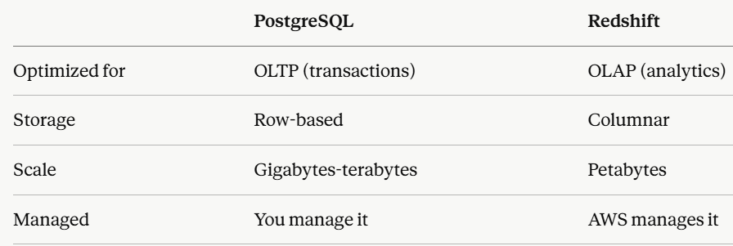
I made Claude make me this^ It says Postgres but it’s applicable to SQL in general.
I also liked this quote from it: “Redshift trades the flexibility of a general-purpose database for raw analytical query performance at massive scale.”

Redshift Architecture
- Redshift primarily deals with big data workflows. To be able to process petabytes of data quickly, AWS has a lot going on under the hood.
  - The curriculum mentions 4 architectural components - Clusters, Nodes, Columnar Storage, and MPP.
Clusters and Nodes
- A Cluster is the core unit of any Redshift deployment. Clusters are collections of Nodes. We see this pattern ALL the time in cloud computing.
  - There are two types of Nodes to know:
- Leader Node
Receives queries, builds an execution plan, and coordinates the compute nodes. It’s like the traffic controller. It delegates processing work basically.
- Compute Nodes
Where data actually lives and query execution happens. Each node processes a piece of the data independently and in parallel. Very efficient behavior!
- We can manually create clusters - you'd have to configure things like compute power, storage capacity, and network settings yourself.
  - Or… we can just use Redshift Serverless, which is the default. It abstracts all of this stuff away and scales up/down as needed. So you should know HOW it works, but I won’t make us mess with it too much.
Columnar Storage
- As mentioned in the table above, Redshift and other DWH or analytical DBs store data in a columnar format.
  - In contrast to relational databases which use row storage. If you want to calculate the average salary across 10 million employees in a SQL DB, it reads every column of every row even though you only need the salary.
- Columnar Storage is INTEGRAL to Big Data and OLAP workflows because analytical queries typically only care about a handful of columns across millions of rows.
  - So Columnar Storage lets Redshift skip entire columns it doesn't need, dramatically reducing how much data it has to read from disk.
    - Makes sense right? Less data processed = quicker processing.
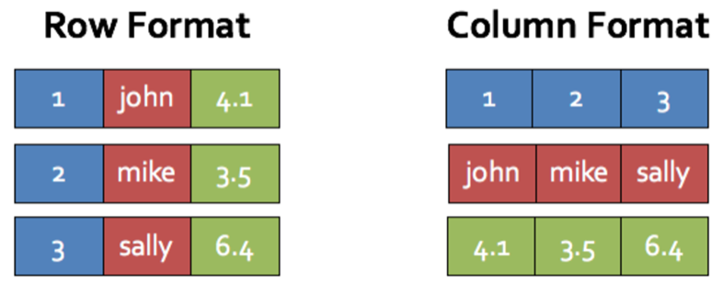
(This picture is a heavy generalization on what data at rest may look like in each format)
MPP
- MPP stands for Massively Parallel Processing. THIS is what makes Redshift capable of processing petabytes of data in a relatively short time.
  - We alluded to this when talking about clusters/nodes. We have multiple nodes in a cluster that split up the work, cutting down processing time. We could even take it a step further and have multiple clusters for the same data source.
*When the Leader Node receives a query, it distributes the work across ALL Computes Nodes Simultaneously.
This diagram explains it better than I would have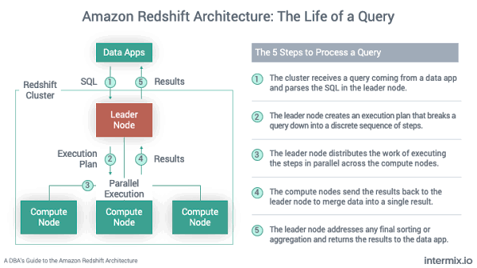

Using Redshift
- It’s pretty easy to connect Redshift to DBeaver, and the queries we write are going to look very similar to our Postgresql scripts. Observe:
Creating a Redshift Cluster
- Note: These are general steps, and we’ll have to see what it actually looks like in FNMA’s environment.
  - You COULD do this on your personal machines, but make sure to use the free trial if you do.
- Search Redshift in the AWS console -> click Try Redshift Serverless (or "Get started" depending on the sandbox view)
You'll set up a few things:
- Namespace
  - The container for your data (databases, users, schemas). You can name it something simple like “demo-namespace”
- Workgroup
  - The compute layer that processes your queries. Similarly, name it something simple like “demo-workgroup”
- IAM role
  - Either create a new one with default settings or use an existing one. This lets Redshift talk to other AWS services. Default is fine here.
- Admin credentials
  - Set your admin username and password here. Write these down or just keep it simple like “user” and “password”. You’ll need these for DBeaver connection
Leave everything else as default and hit Save configuration. Wait a minute or two for status to show Available. Then, you can find your endpoint URL under the workgroup details.
DBeaver Connection Steps
It’s not particularly different from connecting to any other DB type in DBeaver
- Hit the “plug with a plus” button we were clicking all last week
- Choose Amazon Redshift
- Connection Details:
  - Your Redshift endpoint found in the AWS console
  - Port is 5439
  - Leave the database as “dev”
  - Username and password are whatever you set during cluster creation
- Always a good idea to hit “Test Connection” before hitting finish
Querying RedShift
- Again, really nothing different from regular SQL. It IS regular SQL, just on a massive scale.
Here are some queries we saw in my quick demo:
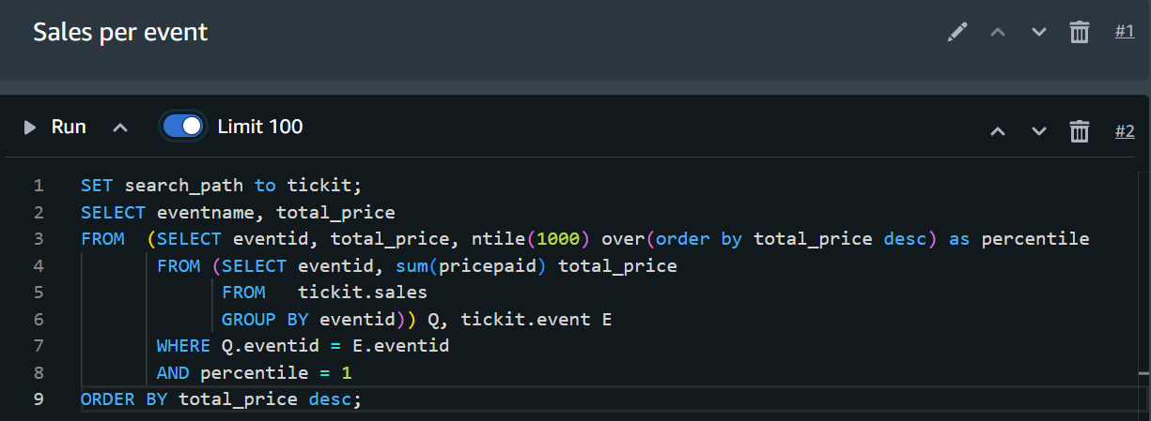
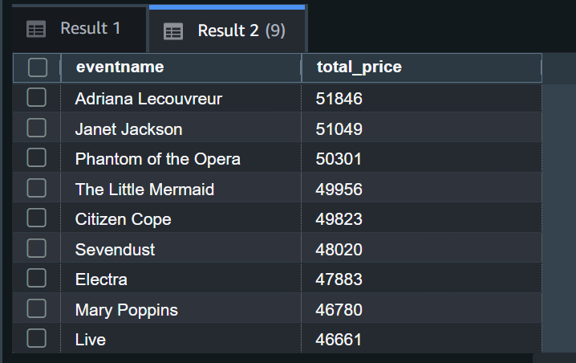

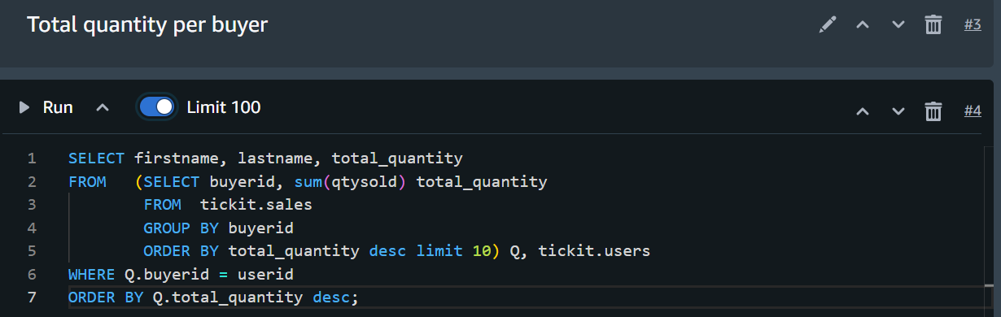
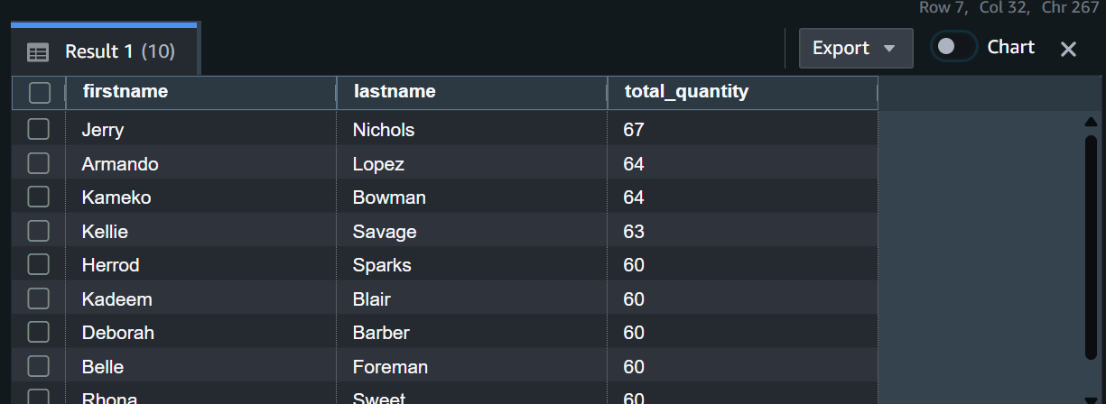

We were able to perform analytical queries (more complex than our webapp-based queries) on massive datasets in less than a second! The power of Data Warehousing services.

